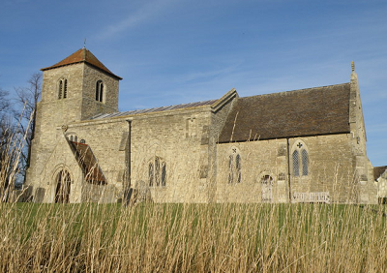Transport – by road
Covington is easily accessible from the A14 – take the Catworth exit, and head towards and through Catworth down the B660. Beyond Catworth you will come to a farm on your right and a sign pointing to Covington. Turn into this road and continue for about 5 minutes – the road is a little uneven so take it slowly. At the entrance to Covington, take the right turning at the T junction and continue up the road a short way. We are excavating in a field on the left - enter via the track to Manor House, and immediately turn left and park in the field. PE28 0RU.

Covington church, near the dig site

Public transport
There is a regular bus from St Neots to Tilbrook (the next village). Bus times everyday excluding Sunday:
St Neots – White Horse, Tilbrook: 8:30, 10:30, 12:30
White Horse, Tilbrook - St Neots: 12:00, 2:00, 5:00
The dig site is a 20-30 minute walk from the White Horse. We may be able to arrange for someone to pick you up/drop you off at Tilbrook.
More information can be found here: http://covington.org.uk/quicklinks/localservices.shtml

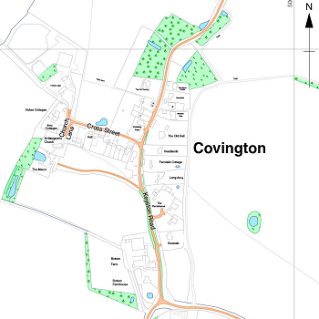Accommodation
There will be limited camping spaces for tents in the Village Hall garden including access to toilet and kitchen facilities in the village hall at a small charge.
There is a Caravan Club site available to Club members in the village, and several nearby B&Bs:
http://www.covington.org.uk/quicklinks/placestostay.shtml

Jigsaw Training Dig Programme
Sat 4th - Sat 18th July, Covington,
nr Kimbolton

We will be investigating a possible Medieval site. Unless otherwise stated, each day will begin at 10am and finish at 4pm. Participants are requested to book for a minimum of 2 consecutive days and a maximum of 5 (not necessarily consecutive) days. The dig is free and priority is given to Jigsaw group members. Tea and coffee are provided, but you will need to bring your own packed lunch.

Alongside hands-on training in excavation and recording methodologies, we will also be running field school talks at lunchtimes (c.12-1pm) to provide more in depth training. Courses from the Jigsaw Training Programme in EA5 and EA6 Medieval Pottery-making Demonstration and EA7 Building a Roman Brick Kiln Practical will also take place during the dig.

The dig is primarily for people with limited skills in excavating features, who may have only conducted testpitting before, or those wishing to refresh their skills. We're also interested in recruiting a few more-experienced Jigsaw archaeologists from the groups to help supervise areas of the dig and give field school talks. You'll also be given the opportunity to shadow Oxford Archaeology East archaeologists at certain points in the day.

Finds processing opportunities will be available for those with a particular interest in this, or those who do not wish to dig all the time. Please express interest in this on your booking form. Since we won't know how many finds we will recover till the excavation, it is impossible to say how much finds processing will be required on a daily basis.
Activity Field School talks
Sat 4th Dig set-up and machine-watching. Start cleaning Discuss site location,
and pre-ex plan if time. Aimed at group leaders recording methodology,
and fieldwork supervisors. Limited spaces. health and safety.

Sun 5th Clean site and start excavating features Context recording

Mon 6th Excavation and recording of features History and archaeology
of Covington
Tues 7th Excavation and recording of features and site Drawing sections and plans
planning

Wed 8th Excavation and recording of features ---
9–11.30am EA5 Medieval Pottery-making Demonstration - booking required
12.30–3pm EA6 Medieval Pottery-making Demonstration - booking required

Thurs 9th Excavation and recording of features and taking Finds recording
levels to add to site drawings

Fri 10th Excavation and recording of features Covington pottery ID

Sat 11th Excavation and recording of features Context recording (repeat)
4.30pm site tour, 6pm BBQ

Sun 12th Excavation and recording of features and site Environmental sampling
planning

Mon 13th Excavation and recording of features and taking History and archaeology of
levels to add to site drawings Covington (repeat)

Tues 14th Excavation and recording of features ---
10am-4pm EA7 Building a Roman Kiln Practical - booking required

Wed 15th Excavation and recording of features. Kiln firing Taking archaeological
all day (drop in). photographs

Thurs 16th Excavation and recording of features and site Drawing sections and plans
planning. Kiln opening (drop in). (repeat)

Fri 17th Excavation and recording of features and taking Human remains recording
levels to add to site drawings. Clean site.
6pm site tour for Covington residents

Sat 18th No excavation. 10-11am Training of volunteer site tour guides.

Festival of Cambridgeshire Archaeology
Sat 18th July, 12 noon – 3pm Covington, near Kimbolton

Displays of Jigsaw groups’ work and site tours of the Training Dig excavation.
Pottery from the Roman kiln available for sale. BBQ and refreshments available for purchase.
Children accompanied by an adult welcome, but no child-specific activities provided.

